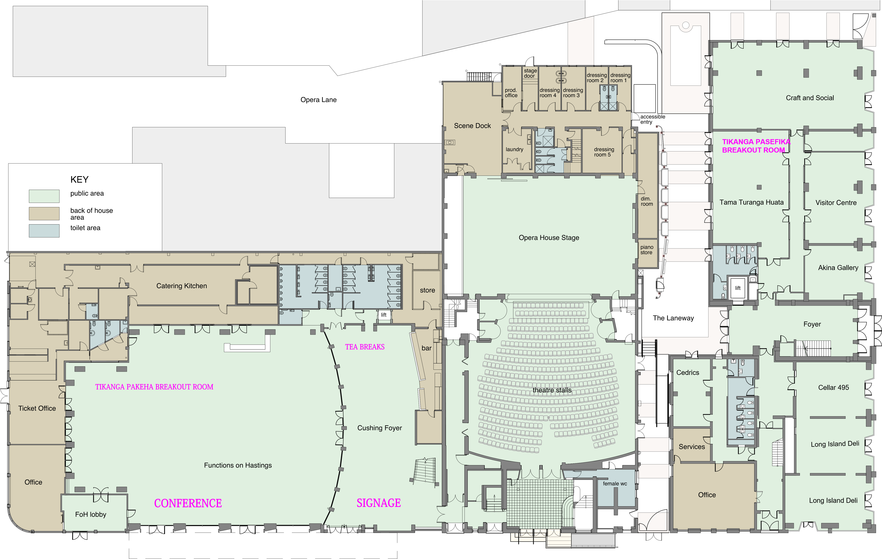
Ground Floor Plan 0 10 15 20 25 30 35 40 45 50 M

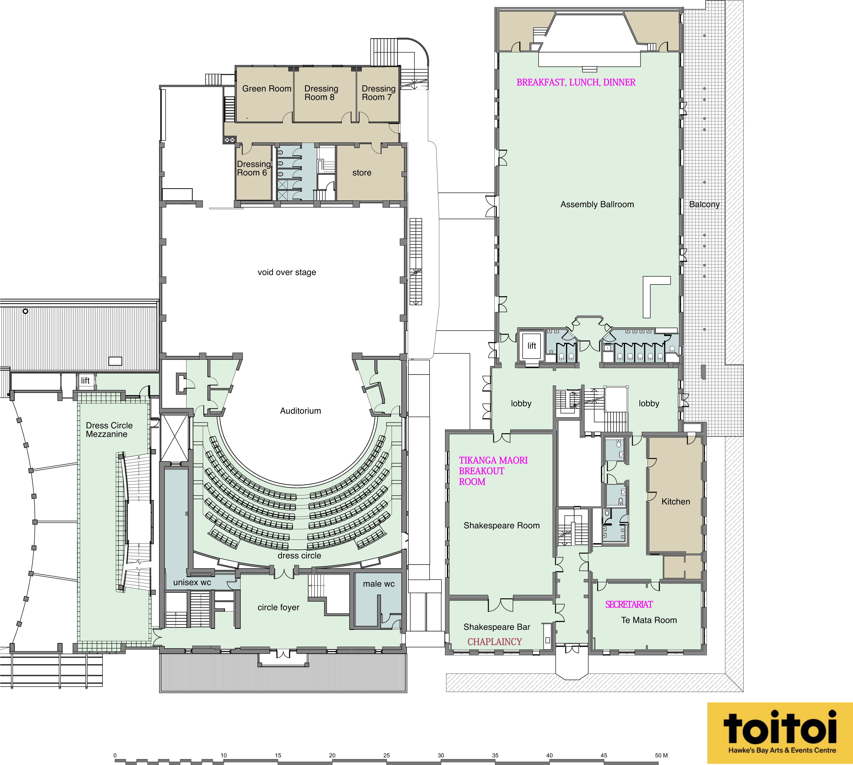
KEY
public area
back of house area
toilet area
First Floor Plan

